**AN EFFICIENT IMAGE RESTORATION METHOD WITH TEMPORAL INFORMATION FOR A CORRUPTED IMAGE IN A NOISY ENVIRONMENT**

**A PROJECT REPORT**

***Submitted by***

**THANUSH KUMAR V 211418104292**

**THANESH N T 211418104291**

**SRINIVASAN M 211418104265**

***in partial fulfillment for the award of the degree of***

**BACHELOR OF ENGINEERING**

***in***

**COMPUTER SCIENCE AND ENGINEERING**



**PANIMALAR ENGINEERING COLLEGE**

**(An Autonomous Institution, Affiliated to Anna University, Chennai)**

**MAY 2022**

**PANIMALAR ENGINEERING COLLEGE**

**(An Autonomous Institution, Affiliated to Anna University, Chennai)**

**BONAFIDE CERTIFICATE**

Certified that this project report **“AN EFFICIENT IMAGE RESTORATION METHOD WITH TEMPORAL INFORMATION FOR A CORRUPTED IMAGE IN A NOISY ENVIRONMENT”** is the bonafide work of **“THANESH N T (211418104291), THANUSH KUMAR V (211418104292), SRINIVASAN M (211418104265)”** who carried out the project work under my supervision.

**SIGNATURE SIGNATURE**

**Dr.S.MURUGAVALLI,M.E.,Ph.D. Mrs.V.ANITHA MOSES,M.E,Ph.D.**

**HEAD OF THE DEPARTMENT PROFESSOR**

DEPARTMENT OF CSE, DEPARTMENT OF CSE,

PANIMALAR ENGINEERING COLLEGE, PANIMALAR ENGINEERING COLLEGE, NAZARATHPETTAI, NAZARATHPETTAI,

POONAMALLEE, POONAMALLEE,

CHENNAI-600 123. CHENNAI-600 123.

Certified that the above mentioned students were examined in End Semester project viva-voice held on _________________________.

**INTERNAL EXAMINER EXTERNAL EXAMINER**

## DECLARATION BY THE STUDENT

We **THANUSH KUMARV (211418104292), THANESH N T (211418104291) &**

**SRINIVASAN M (211418104265)** hereby declare that this project report titled “**AN EFFICIENT IMAGE RESTORATION METHOD WITH TEMPORAL INFORMATION FOR A CORRUPTED IMAGE IN A NOISY ENVIRONMENT**”, under the guidance of **Mrs.V.ANITHA MOSES,M.E,Ph.D.**is the orginial work done by us and we have not plagiarized or submitted to any other degree in any university by us

**ACKNOWLEDGEMENT**

We express our deep gratitude to our respected Secretary and Correspondent **Dr.P.CHINNADURAI, M.A., Ph.D.** for his kind words and enthusiastic motivation, which inspired us a lot in completing this project.

We would like to express our heartfelt and sincere thanks to our Directors

**Tmt.C.VIJAYARAJESWARI**, **Dr.C.SAKTHIKUMAR, M.E., Ph.D.,** and

**Dr. SARANYASREE SAKTHIKUMAR B.E., M.B.A.,** for providing us with the necessary facilities for the completion of this project.

We also express our gratitude to our Principal **Dr.K.Mani, M.E., Ph.D.** for his timely concern and encouragement provided to us throughout the course.

We thank the HOD of the CSE Department, **Dr. S.MURUGAVALLI, M.E., Ph.D.,** for the support extended throughout the project.

We would like to thank my **Project Guide Mrs.V.ANITHA MOSES, M.E., Ph.D.,** and all the faculty members of the Department of CSE for their advice and suggestions for the successful completion of the project.

**THANESH N T**

**THANUSH KUMAR V**

**SRINIVASAN M**

**ABSTRACT**

The long-standing low-level vision issue in deep learning is the process of image restoration. Deep learning algorithms are used to improve image quality by discretizing corrupted photos from high-quality photos. During the image capture process, the image becomes corrupted due to the presence of haze, motion blur, and lens blur, resulting in low quality images with noise. Photographing in less-than-ideal conditions necessitates post-processing, such as JPEG image corruption occurs as a result of compression. The blurred images are restored along with the temporal relationship in video frames due to the presence of noisy, compressed, and downscaled images. In existing the use of variational autoencoders results in low quality images in noisy condition. The proposed VRT (Video Restoration Transformer)used for video restoration (e.g., video super-resolution) seeks to recover high-quality frames from low-quality frames. Video restoration, as compared to single image restoration, typically requires the use of temporal information from multiple adjacent but usually misaligned video frames. The Video Restoration Transformer (VRT) in this case is capable of parallel frame prediction as well as long-range temporal dependency modelling.

**TABLE OF CONTENTS**

**CHAPTER NO. TITLE PAGE NO. ABSTRACT i**

**LIST OF TABLES ii**

**LIST OF FIGURES iii**

**LIST OF ABBREVIATIONS iv**

1. **INTRODUCTION 1** 
   1. OVERVIEW 1
   2. PROBLEM DEFINITION 1
2. **LITERATURE SURVEY 3**
3. **SYSTEM ANALYSIS 7**
   1. EXISTING SYSTEM 7

* 1. PROPOSED SYSTEM 7
  2. REQUIREMENT SPECIFICATION 8
     1. INPUT REQUIREMENTS 8
     2. OUTPUT REQUIREMENTS 9
     3. FUNCTIONAL REQUIREMENTS 9
  3. TECHNOLOGY STACK 10

**CHAPTER NO. TITLE PAGE NO.**

1. **SYSTEM DESIGN 13**

4.1. DATA DICTIONARY 13

* 1. UML DIAGRAMS 14

4.2.1 CLASS DIAGRAM 14

4.2.2 ACTIVITY DIAGRAM 15

4.2.3 DEPLOYMENT DIAGRAM 16

1. **SYSTEM ARCHITECTURE 18**
   1. ARCHITECTURE OVERVIEW 18

5.1.1 ARCHITECTURE DIAGRAM 20

* 1. MODULE DESIGN SPECIFICATION 21

1. **SYSTEM IMPLEMENTATION 31**
   1. CLIENT-SIDE CODING 31
   2. SERVER-SIDE CODING 33
2. **TESTING 35**
   1. UNIT TESTING 35
   2. INTEGRATION TESTING 38
   3. TEST CASES & REPORTS 38
3. **CONCLUSION 44**
   1. CONCLUSION AND FUTURE ENHANCEMENTS 44

**APPENDICES 46**

* 1. PLAGIARISM REPORT 47

**REFERENCES 49**

**LIST OF ABBREVIATIONS**

|  |  |
| --- | --- |
| **ABBREVIATION** | **DESCRIPTION** |
| VAE | Variational Auto Encoder |
| GMM | Gaussian Mixture Model |
| FMRI | Functional Magnetic Resonance Imaging |
| BCCA | Bayesian Canonical Correlation Analysis |
| DE-CNN | Deconvolution Neural Network |
| DGMM | Deep Generative Multiview Model |
| TDNN | Twin Deep Neural Network |

**LIST OF TABLE**

**TABLE NO** **TITLE**  **PAGE NO.**

4.1.1 DATA DICTIONARY 13

7.1.1 TESTING HOMEPAGE 34

7.1.2 TESTING TRAINING SCREEN 34

7.1.3 TESTING RESOURCES 35

7.1.4 TESTING RESULT SCREEN 35

7.1.5 INTEGRATION TESTING 36

**LIST OF FIGURES**

**FIGURE NO TITLE PAGE NO.**

3.4.1 TECHNOLOGY STACK 11

4.1.2 CLASS DIAGRAM 14

4.1.3 ACTIVITY DIAGRAM 15

4.1.4 DEPLOYMENT DIAGRAM 16

7.2.1 INTEGRATION DIAGRAM 37

A.1 INPUT IMAGE 37

A.2 MEANS DENOISING 38

A.3 DENOISE OF CHAMBOLLE 38

A.4 FRAMES OF INPUT VIDEOS 39

A.5 VRT METHOD 39

**INTRODUCTION**

1. **INTRODUCTION**

**1.1 OVERVIEW**

Understanding the visual processing of the input images/videos is a critical and challenging problem in old days. Revolutions of mathematical and probabilistic models in the computer field are applied to many sorts of applications including detection, computer vision, and classification problems. In the first, processing of the Denoising is implemented by linear models and later the development of perceptron is more useful and has the natural properties of the Denoising and improved the model performance but a complex structure of visual stimuli and high dimension data is challenging issues although the feature sample for many sorts of application is different and is simplified after the emerging of convolution neural network is a more upgradeable version of deep neural network and also it has good feature extraction in the model help to improve accuracy and overcome the problem of high dimensional data.

* 1. **PROBLEM DEFENITION**

Construction of High quality Images of Recognized Image from Denoising activity for understanding the human visual system and Implement the variational autoencoder by convolutional neural network for visual representation then Gaussian mixture model is used to cluster the same variants of class in latent space vector. The generative model is to reconstruct the visual images and classify the reconstructed image from the original images by image classification algorithms.

**LITERATURE SURVEY**

**2. LITERATURE SURVEY**

**Bayesian Deep Multi-View Learning** [1] used both neural encoding as well as decoding to reconstruct the visual stimuli correspond to the voxel activation which is proposed through different stages of visual stimuli categorization. It uses a convolution neural network with the major properties variational autoencoder for the image compression of visual stimuli and voxel activation was computed by fMRI. For Construction of High quality Images of visual images is generated by using a deep neural network and Construction of High quality Images of voxel activation is generated by the linear model for greater improvement but there is a major problem in the dataset with high dimension feature and also complex data with more noise capture during the preparation of dataset affect the model and accuracy.

**Unsupervised Domain Adaptation** [2] Decoding Restoration States from fMRI is decoding the voxel active areas in the restoration and the framework is used for capture the high dimension feature in spatiotemporal data. To capture different distribution spaces with the most efficient classification method is used as a meanest discrepancy.

The difference capture from the source and predictive target distributions is correlated and analyzed using the domain adaptation method. The decoding of the voxel activation is trained using unsupervised learning due to the limited of datasets and also a large amount of data is unlabeled so basic fundamental linear models take more time than unsupervised learning.

**Efficient Perceptual Coding** [3] converting the original signal to elements of new forms that represent a coding rate are independent and the reconstructed image of visually seen is effectively generated by minimizing the error loss in model from the latent quantize of elements in a new form is statistically and perceptually not dependent on each other. The basic fundamental linear models for this approach are not effective so that the proposed adaptive nonlinear method analysis the new elements and their weights to find the likelihood of generated neighborhood. The developed effective coding method is good to reconstruct the images with high quality of input signal with their original images.

**Neural Decoding with Hierarchical Generative Models** [4] learns and extracts features based on the combination of different models so that model is highly trained to learn the all hierarchy important data by using different generative models to reconstruct the visual stimuli done by Boltzmann machines with the upgraded version of the conditionally restricted machine. In first, extract the important feature of data from voxel active areas done by unsupervised phase because of the large amount of unlabeled data is available. The extracted data feature is then trained using hierarchical generative models to get the reconstructed image of visual stimuli.

**Locally Adaptive Perceptual Image Coding** [5] capture the difference of original image data with their important feature of components. The coder method is for the dimension reducing technique of the original image as well as input signal and they used reconstructed image quality on sub-band transform coefficient.

The proposed coder method does not use more information of image so this method reduces the computation of more redundant statistics data.

**High Quality Realistic Image** [6] with the generative models by mapping the voxel activation by the CNN to capture more important features and then combining the GAN to reconstruct the image. An important feature is easily captured by CNN to get a lower set of values store in latent space from this GAN is used to reconstruct the image and evaluated the quality and computation of the model.

**The high-Dynamic-Range-Based** [7] method is proposed for the display of the original image in that criteria there are two forms of media are highly dynamic and low dynamic of details for image with the novel of adding additional edge capture filter is used to reconstruct the original image with non-volatile of image detail.

**Decoding Behavior Task** [8] is to get the visual data of voxel activation of the restoration. The noninvasive detection method is mainly focused on correlating the voxel data to the visual data. The proposed cross-subject decoding uses existing trained models on ImageNet to get the feature from the voxel activation.

**Human Vision Construction of High quality Images** [9] understands the restoration activity with all criteria occur in occipital lobe active areas are to be capture without the noise. Analysis of restoration for single data is not exactly well served so different situation of visual stimuli is seen by the person at the same time to record the voxel activation of the entire restoration. Mapping the voxel to the corresponding visual is a challenge and to predict the model for a specific set of voxel corresponding mapping space is also potentially need for the model. A novel mapping algorithm is proposed to mapping the restoration voxel activation areas to visual stimuli like real faces or handwritten digits with fMRI. The Construction of High quality Images is entirely lying on the mapping algorithm that captures the voxel activation pair to visual stimuli.

**Tensor Neural Network** [10] was used for better analysis of high dimension as well as complex categorical voxel activation on the entire restoration. The proposed framework in this paper is to capture all voxel activation data across the entire restoration and remove the problem of higher dimension so that the captured feature is quite good with essential features. Analysis of this framework to existing work came up with the result of high accuracy and superior model to capture voxel data with complex structure and high dimension is no problem with the proposed framework and is implemented by a neural network with a high number of nodes in each layer to get compress the feature having more weight parameters in the neural network.

**SYSTEM ANALYSIS**

1. **SYSTEM ANALYSIS**
   1. **EXISTING SYSTEM**

The existing system consists of a restoration decoding model using the state of the art. This system has various faults in its own way. The one major problem with this system is that it couldn't capture the neuron interactions at the micro-level. The system is using EEG signals, which are just the general electrical impulse signals from various probes. This procedure creates a limitation of identifying the overall restoration activity. These systems can map an extent to 40 probe signals at max, which in turn fed to a neural network yields a very under the fitted model. The complex nature of the working of the Denoising is still a mystery and it is highly difficult to capture a snapshot of the restoration activity for a given moment, as billions of neuron's firings happen even in a simple activity. And, finding the pattern among the communication of these neurons is still an unsolvable mystery.

* 1. **PROPOSED SYSTEM**

Visual image and FMRI restoration activities are used as input to the inference model and implemented by Variation Auto Encoder to get the similarity of both images using a neural network. Digits are multi-model distribution multiple peaks. Multiple Gaussian in different proportions simultaneously to approximate a multi-modal distribution. GMM is a latent variable model and trained using the Expectation-Maximization algorithm to find a closed multi-model distribution. GMM finds the number of finite clusters. Latent space is a smaller dimension representation of restoration activity and smooth transformation of images from one another. The decoder model is to Reconstruct Images from latent space using posterior probability or prior probability. Transform latent space representation to higher dimension images using the generative model for the Construction of High quality Images.

* 1. **REQUIREMENT ANALYSIS AND SPECIFICATION**
     1. **INPUT REQUIREMENTS**

The proposed system is expected to receive two different types of datasets such as visual stimuli and restoration mappings. The dataset creation involves the use of functional magnetic resonance imaging equipment and a head-mountable image visualizer device. The subject is laid on an FMRI machine with a head-mounted device and is projected to different visual image frames. The FMRI machine is then activated and a magnetic resonance is passed to the human subject, the respective cross-section views of the restorations are then plotted and then integrated as a 3D restoration voxel of 3092 segments. Now, this 3D restoration depicts two restoration behaviors such as active and dormant. These active regions represent the flow of blood on a particular part of the cerebrum. The 3D restoration is then processed into a 2D flat map surface which is further streamlined into a 1D plane. This conversion process from 3D into 1D helps us to capture the majority of the restoration activities. These restoration activities are then treated as one of the types of input datasets. During this process, the visual frames subjected to the human are treated as another type of dataset.

* + 1. **OUTPUT REQUIREMENTS**

The proposed system is expected to reconstruct images with the help of visual stimuli and restoration mappings. The subject is laid on an FMRI machine with a head-mounted device and is projected to different visual image frames. The FMRI machine is then activated and a magnetic resonance is passed to the human subject, the respective cross-section views of the restorations are then plotted and then integrated as a 3D restoration voxel of 3092 segments. Now, this 3D restoration depicts two restoration behaviors such as active and dormant. These active regions represent the flow of blood on a particular part of the cerebrum. The 3D restoration is then processed into a 2D flat map surface which is further streamlined into a 1D plane. This conversion process from 3D into 1D helps us to capture the majority of the restoration activities. These restoration activities are then treated as one of the types of input datasets.

* + 1. **FUNCTIONAL REQUIREMENTS**

The system is expected to receive two different types of datasets as inputs namely – visual images, restoration mappings. With the perception of datasets fed to an inference model, it is expected to derive an encoding schema from the input visual stimuli dataset. The inference gained from the encoding model is subjected to shared latent space. The knowledge-based system is further utilized for the generative multi-view model. This generative model is capable of reconstructing images from the shared knowledge-based and the input visual stimuli dataset. To further evaluate the quality of images reconstructed, it is passed to different classification algorithms to determine the accuracy in the classification of different labels. This can be achieved by bypassing the traditional MNIST dataset and the reconstructed image dataset into the classifier algorithm.

* 1. **TECHNOLOGY STACK**

The major tools that have been used in our project are

* ANACONDA
* ANGULAR 10
* TENSORFLOW
* KERAS
* FLASK
* BOOTSTRAP
* NODE

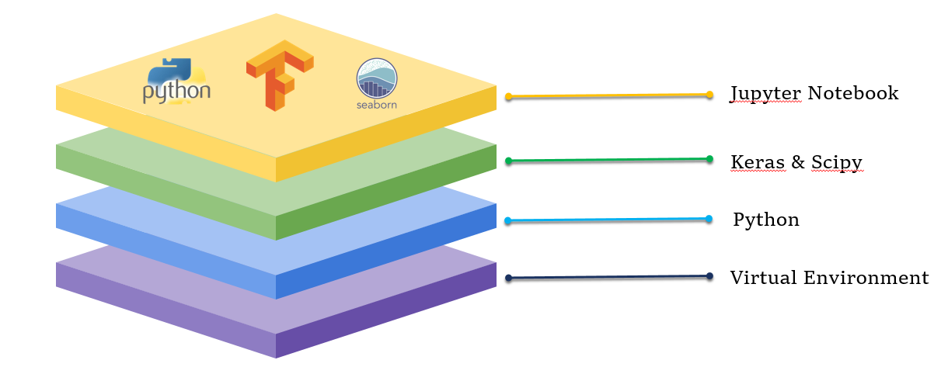

FIGURE 3.4.1 - TECHNOLOGY STACK

Anaconda Navigator is the latest python repository and also it has been used to initiate applications with a major ide provide environment. It is free software for all users with python and r programming languages that are emerging in mathematical models and computer vision. It has been provided with the user interface as well as a command-line that is greatly helpful to users. It has integrated with the pre-built library packages and channels for programming languages.

Spyder is a cross platform python programming ide for mathematical models and computer vision. It is free software for all users integrates with basic package of python and also includes mathematical models packages like numpy, pandas, etc. It is best ide for project work and included in anaconda navigator for easy to install packages at once.

**SYSTEM DESIGN**

1. **SYSTEM DESIGN**

**4.1. DATA DICTIONARY**

|  |  |  |
| --- | --- | --- |
| **Data** | **Type** | **Size** |
| **FRONT-END** | | |
| Home | Root directory | 10kb |
| Trainer | Root bridge | 12kb |
| Resources | Artifact directory | 10kb |
| Chartlist | Training summary list | 13kb |
| Charts | Evaluation graphs | 15kb |
| Footer | Root bridge | 12kb |
| **BACK-END** | | |
| Main.py | REST API | 5kb |
| Driver.py | Driver | 3kb |
| Inference_model.py | Globalizer | 4kb |
| Shared_latent_space.py | Shared space | 5kb |
| Decoder_train.py | Decoder | 4kb |
| Dual_learning.py | Space updater | 6kb |
| Training.py | Trainer | 5kb |
| Testing.py | Testing | 5kb |
| Classification.py | Classifier | 7kb |
| Data | Data directory | 50MB |
| Plots | Plot directory | 35MB |

4.1.1 - DATA DICTIONARY

**4.2. UML DIAGRAMS**

**CLASS DIAGRAM**

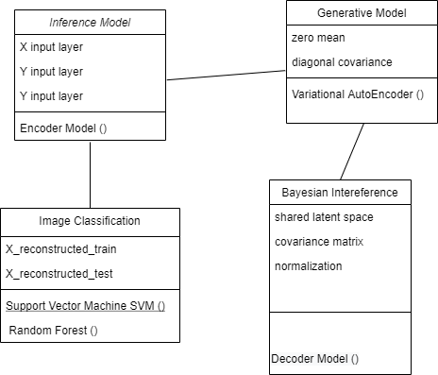

FIGURE 4.1.2 - CLASS DIAGRAM

**ACTIVITY DIAGRAM**

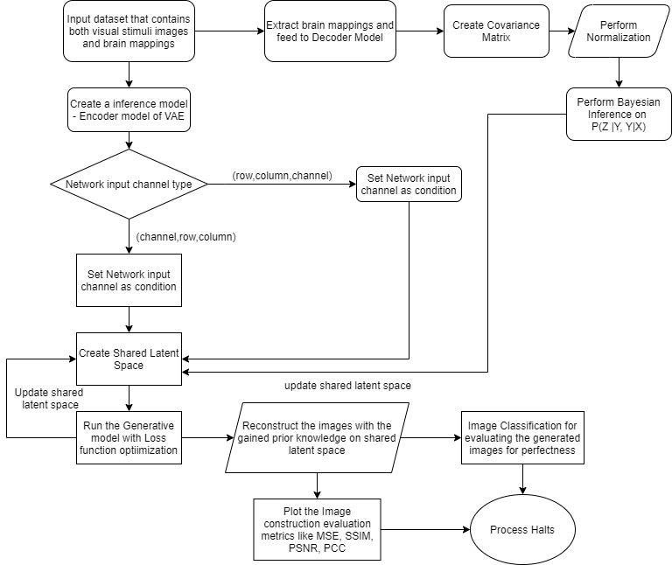

Figure 4.1.3 - ACTIVITY DIAGRAM

**DEPLOYMENT DIAGRAM**

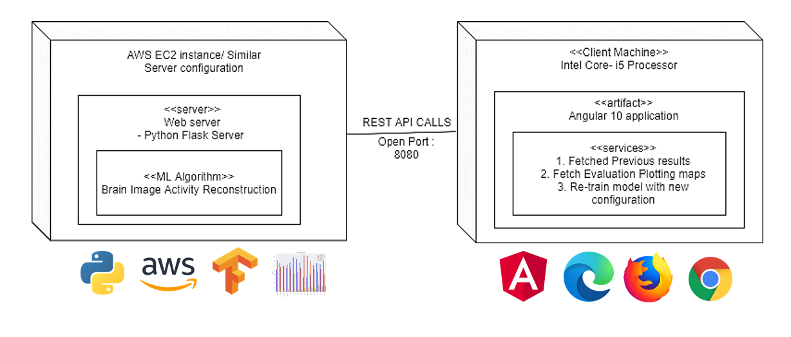

Figure 4.1.4 - DEPLOYMENT DIAGRAM

**SYSTEM ARCHITECTURE**

1. **SYSTEM ARCHITECTURE**

**5.1. ARCHITECTURE OVERVIEW**

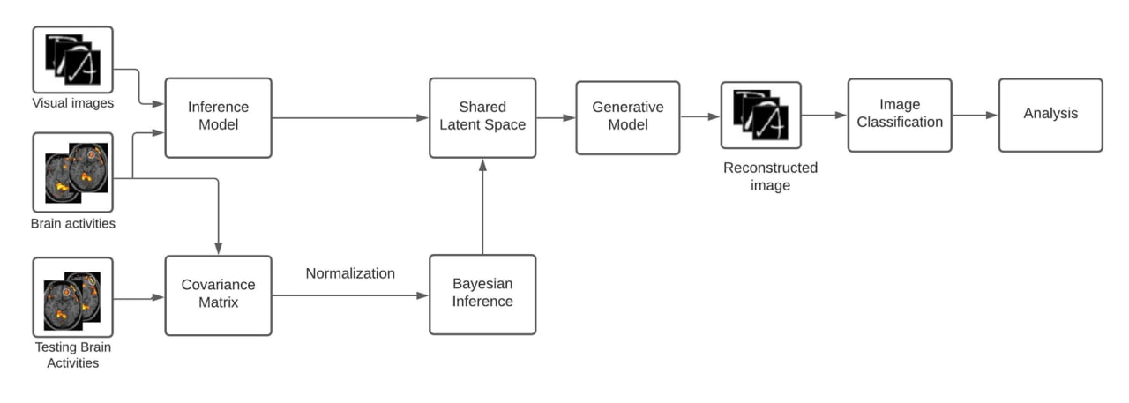

Figure 5 – ARCHITECTURE OVERVIEW

The proposed model consists of three modules. The first stage involves the gathering of input data such as visual handwritten digits, FMRI restoration activity from the restoration linear repository and fetching the gathered data to the inference model and GMM is used to cluster. The second stage involves the shared latent variables used to represent the low dimensional images and get input from the inference model. The final stage involves the Construction of High quality Images of visual image using generative model. Figure 4 picturizes the overall proposed architecture.

**NEURAL NETWORK ARCHITECTURE**

Model: "TDNN"

_______________________________________________________________________________

Layer (type) Output Shape Param # Connected to

======================================================================

input_1 (InputLayer) (None, 1, 28, 28) 0

_______________________________________________________________________________

Firstlayer (Conv2D) (None, 1, 28, 1) 113 input_1[0][0]

_______________________________________________________________________________

Secondlayer (Conv2D) (None, 1, 14, 64) 320 Firstlayer[0][0]

_______________________________________________________________________________

Thirdlayer (Conv2D) (None, 1, 14, 64) 36928 Secondlayer[0][0]

______________________________________________________________________________

Fourthlayer (Conv2D) (None, 1, 14, 64) 36928 Thirdlayer[0][0]

_______________________________________________________________________________

flatten_1 (Flatten) (None, 896) 0 Fourthlayer[0][0]

_______________________________________________________________________________

hiddenlayer (Dense) (None, 128) 114816 flatten_1[0][0]

_______________________________________________________________________________

Z_1 (Dense) (None, 6) 774 hiddenlayer[0][0]

_______________________________________________________________________________

Z_2 (Dense) (None, 6) 774 hiddenlayer[0][0]

_______________________________________________________________________________

lambda_1 (Lambda) (None, 6) 0 Z_1[0][0]

Z_2[0][0]

_______________________________________________________________________________

dense_1 (Dense) (None, 128) 896 lambda_1[0][0]

_______________________________________________________________________________

dense_2 (Dense) (None, 12544) 1618176 dense_1[0][0]

_______________________________________________________________________________

reshape_1 (Reshape) (None, 14, 14, 64) 0 dense_2[0][0]

_______________________________________________________________________________

conv2d_transpose_1 (Conv2DTrans (None, 14, 14, 64) 36928 reshape_1[0][0]

_______________________________________________________________________________

conv2d_transpose_2 (Conv2DTrans (None, 14, 14, 64) 36928 conv2d_transpose_1[0][0]

_______________________________________________________________________________

conv2d_transpose_3 (Conv2DTrans (None, 29, 29, 64) 36928 conv2d_transpose_2[0][0]

_______________________________________________________________________________

conv2d_1 (Conv2D) (None, 28, 28, 1) 257 conv2d_transpose_3[0][0]

======================================================================

Total params: 1,920,766

Trainable params: 1,920,766

Non-trainable params: 0

**5.1.1. ARCHITECTURE DIAGRAM**

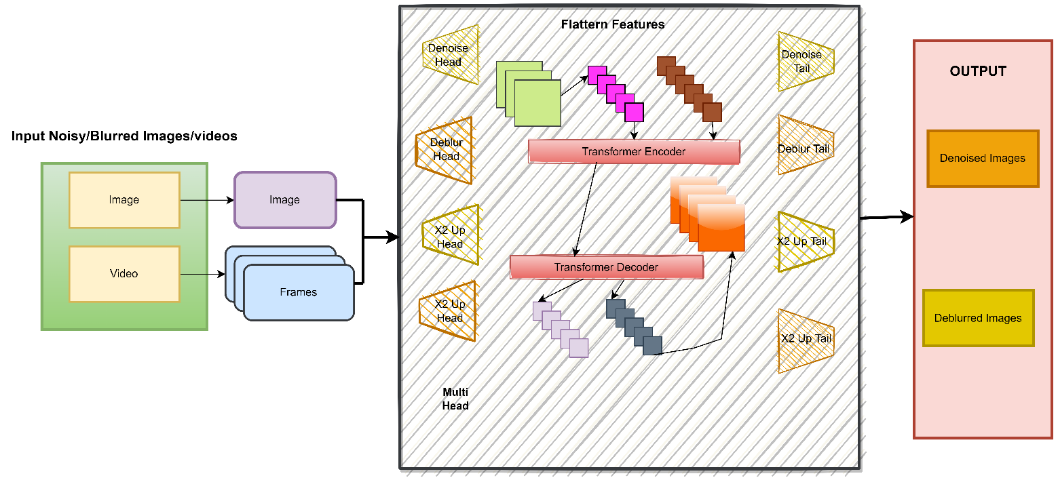

**5.2. MODULE DESIGN SPECIFICATION**

**5.2.1. LINEAR SPARSE DECODING MODEL**

Bayesian Deep Multi View Learning used both neural encoding as well as decoding to reconstruct the visual stimuli corresponds to the voxel activation which proposed through different stages of visual stimuli categorization. It uses convolution neural network with the major properties of variational auto encoder for the image compression of visual stimuli and voxel activation was computed by FMRI. For Construction of High quality Images of visual images is generated by using deep neural network and Construction of High quality Images of voxel activation is generated by linear model for greater improvement but there is major problem in dataset with high dimension feature and also complex data with more noise capture during the preparation of dataset affect the model and accuracy.

Sparsity-Constrained fMRI decoding Natural video provides dynamic restoration response process information of day to day life scenario is recorded by FMRI is helpful in restoration encoding and decoding field of study. In this paper, a novel decoding model with sparsity based approach that insist bottom up method first for decoding the natural real life video scene and to analysis the visual saliency decoding. Visual saliency model is used from graph based algorithm to get curve information of priori saliency is calculated by current video frame integrate with activation map. Specific computational model is adopted and combine with the linear sparse model learn from atomic dictionary to represent the restoration activity pattern signal with correspondence to visual video streams. This sparsity technique is efficient one to decode video and dictionaries to learn and reconstruct the FMRI signals by sparse based model to get restoration activity pattern representation.

**5.2.2 CONSTRUCTION OF HIGH QUALITY IMAGES BY GENERATIVE ADVERSARIAL NETWORK**

Reconstructing Realistic Image with the generative models by mapping the voxel activation by the CNN to capture more important feature and then combining the GAN to reconstruct the image. Important feature is easily capture by CNN to get lower set of values store in latent space from this GAN is used to reconstruct the image and evaluated the quality and computation of model.

High-Dynamic-Range-Based method is proposed for the display the original image in that criteria there is two form of media are high dynamic and low dynamic of details for image with novel of adding additional edge capture filter is used to reconstructed the original image with non-volatile of image detail.

Quality Prediction Realistic images generation and quality of image is important. In this paper, a new realistic natural image quality predictor for reconstructing the images. GAN is combined with boosting system that run parallel to analysis the structural information. The GAN was devised into two groups of features representing structural and statistical information and generative image database comprises reference images that span a wide range of natural scene characteristics. The result of GAN with boosting create accurate image with extreme high quality prediction.

Restoring Latent Vectors In this paper, pre-trained GAN is adopted with global optimization technique or Genetic Algorithm is calculates the candidate solution for selection and restores the values of latent vector from the pre-trained GAN and obtain the parameter performance and functions used to fit the model. The Gradient descent along with the Mean Squared Error showed better performance.

**5.2.3 UNSUPERVISED DECODING MODEL**

Unsupervised Domain Adaptation Decoding Restoration States from FMRI is a decoding the voxel active areas in restoration and the framework is used for capture the high dimension feature in spatiotemporal data. For capture different distribution space with the most efficiency classification method is used as most mean discrepancy. The difference capture from the original source and predictive target distributions is correlated and analysis using the domain adaptation method. The decoding the voxel activation is trained using the unsupervised learning due to limited of datasets and also large amount of data is unlabeled so basic fundamental linear models take more time than unsupervised learning.

Locally Adaptive Perceptual Image Coding capture the different of original image data with their important feature of components. The coder method is for the dimension reducing technique of the original image as well as input signal and they used reconstructed image quality on sub band transform coefficient. The proposed coder method does not used more information of image so this method reduce the computation of more number of redundant statistics data.

**5.2.4 LINEAR GAUSSIAN MODEL**

Linear Gaussian Framework for Decoding of Perceived Images Visualizing the mind of someone is improved after the mathematical model of neural network and decode the thoughts is being a real task. In this paper, a novel simple linear Gaussian model use decoding from inversion of encoding models with some regularization. This model is very flexible to decode the restoration mapping by bayes probability when visual images is able to reconstruct from the encoding knowledge of prior information and Construction of High quality Images of visually seen image are obtained by elastic net and graph net models.

Efficient Perceptual Coding converting the original signal to elements of new forms that represent a coding rate are independent and the reconstructed image of visually seen is effectively generated by minimizing the error loss in model from the latent quantize of elements in new form is statistically and perceptually not dependent on each other. The basic fundamental linear models for this approach is not effective so that the proposed adaptive nonlinear method analysis the new elements and their weights to find the likelihood of generated neighborhood. The developed effective coding method is good to reconstruct the images with high quality of input signal with their original images.

**5.2.5 RECONSTRCTION BY GAUSSIAN MIXTURE MODEL**

Gaussian Mixture Models improve fMRI-based Image Construction of High quality Images [11] Linear Gaussian model able to represent the likelihood distribution of visual images and reconstruct image of visual cortex from bold responses. EM algorithm is adopted in Gaussian mixture model for calculate the values of intermediate stored variable and joint distribution is performed to maximum likelihood of infer variables. Visual images from bold responses consists of different kind of letter categories with variable mixture amount of components. The proposed framework computation is extremely time consuming if there is more number of distribution for different amount of mixture component for all categories of letters used in dataset or else minimum number of input data sample points and it can reconstruct accurate visual images from bold response and also infer variables values correspond to visual cortex region of the restoration.

Hidden Markov models [12] Construction of High quality Images reading words or individual characters from restoration activities is main objective of this paper and from the studies both recognized nerve and visualizing nerve share the same information. Gaussian mixture model is used to represent the individual characters correspond to restoration activity. Hidden Markov model is helpful to find the high level information. These two model combine using graphical model, GMM represent characters through shapes from specific priors from restoration activity. Hidden Markov model is combine with a Gaussian mixture model will increase the decoding accuracy from restoration activity patterns.

**5.2.6 HIERARCHICAL GENERATIVE MODEL**

Neural Decoding with Hierarchical Generative Models [13] learn and extract features based on combination of different models so that model is highly trained to learn the all hierarchy important data by using different generative models to reconstruct the visual stimuli done by Boltzmann machines with upgraded version of conditional restricted machine. The extracted data feature is then trained using hierarchical generative models to get reconstructed image of visual stimuli.

Decoding Behavior Task [14] is to get the visual data of voxel activation of restoration. Noninvasive detection method is mainly focused on the correlating the voxel data to the visual data.

**5.2.7 CATEGORICAL FEATURES MAPPING FRAMEWORK**

Human Vision Construction of High quality Images [15] understand the restoration activity with all criteria occur in occipital lobe active areas are to be capture without the noise. Analysis of restoration for single data is not exactly well served so different situation of visual stimuli is seen by the person at the same time to record the voxel activation of entire restoration. Mapping the voxel to corresponding visual is challenges and to predict the model for specific set of voxel corresponding mapping space is also potentially need for the model. A novel mapping algorithm is proposed to mapping the restoration voxel activation areas to the visual stimuli like real faces or handwritten digits with FMRI. The Construction of High quality Images is entirely lies on the mapping algorithm that capture the voxel activation pair to visual stimuli.

Tensor Neural Network [16] used for better analysis of high dimension as well as complex categorical voxel activation on entire restoration.

The proposed framework in this paper is to capture the all voxel activation data across the entire restoration and remove the problem of higher dimension so that the captured feature is quite good with essential features. Analysis this framework to existing work came up with the result of high accuracy and superior model to capture voxel data with complex structure and high dimension is no problem with the proposed framework and it implemented by neural network with high number of nodes in each layer to get compress the feature having more weight parameters in neural network.

Correlation Network Framework [17] Restoration activation data are to be analyzed through the correlation of visually presented images is mainly focus through a novel decoding framework. The traditional framework only calculate the information strength of voxel activation and functional connection between the voxel and cerebral cortex.

**5.2.8 HIGH DIMENSIONAL IMAGE CONSTRUCTION OF HIGH QUALITY IMAGES**

3D Contrast Image Construction of High quality Images from Denoising Activity [18] Construction of High quality Images of two dimensional perceptual image from FMRI signals using Restoration decoding and encoding techniques. Three dimensional Construction of High quality Images from visual cortex of early and dorsal region is main objective in this paper. The proposed three decoding model with contrast, disparity with combination of both revealed that three dimensional visual images can be reconstructed. In contrast with disparity model can use both early cortex regions and dorsal regions to reconstruct the contrast with disparity based three dimensional images. The two different models are well combine with each other and decoder output of contrast and disparity model were combined by a linear model of the corresponding image wise to reconstruct the visual images in three dimensional.

Image-Specific Classification with Local and Global Discriminations [19] Classifier learns different kind of class to predict the image, most of the classifier algorithm are train the classifier and then test the classifier. In testing phase, classifier is unable to variate multi modal distribution, inter class and intra class of images so classifier fails to predict the class of image. In this paper, the novel Image classification with specific set of local and global discriminations. In local phase, classifier training is done normally as same but in global phase classifier is trained for testing image by randomly selected nearest neighbor of test image in training samples to force the classifier to learn the intra class variations. The proposed model can classify all multi modal distribution and combine the two discriminations of local and global for improve in prediction of class and evaluation of proposed image specific classification model show better result than the existing classifier.

Multispectral Image Construction of High quality Images [20] Multi Spectral Images can show important spectral information when compare to normal RGB images from this images Multi spectral images can be created but there is loss of information. In this paper, the main objective is Construction of High quality Images of Multi Spectral images. Combination of VAE with GAN can improve the model accuracy and also reduce the loss of quality. One input RGB image with random latent space vectors can be created out of the lost possible multiple outputs. VAE can solve major problem of loss information by parameterizing technique of latent space vectors with normalization. GAN model is used to regenerate Multi Spectral images from the latent space vectors. GAN is one of the trending models for Construction of High quality Images of images and it could give accurate results with minimum number of training and quality of reconstructed images is evaluated by both Qualitative and Quantitative analysis is performed and get better result from the existing methods.

**SYSTEM IMPLEMENTATION**

**6.SYSTEM IMPLEMENTATION**

**CLIENT-SIDE-CODING**

import cv2

import numpy as np

from matplotlib import pyplot as plt

from matplotlib import *

plt.style.use('seaborn')

image = cv2.imread('/content/drive/MyDrive/B.E project/restoration/nois and blur/colored noise 2.jpg')

dst = cv2.fastNlMeansDenoisingColored(image, None, 11, 6, 7, 21)

row, col = 1, 2

fig, axs = plt.subplots(row, col, figsize=(15, 10))

fig.tight_layout()

axs[0].imshow(cv2.cvtColor(image, cv2.COLOR_BGR2RGB))

axs[0].set_title('Elephant')

axs[1].imshow(cv2.cvtColor(dst, cv2.COLOR_BGR2RGB))

axs[1].set_title('Fast Means Denoising')

plt.show()

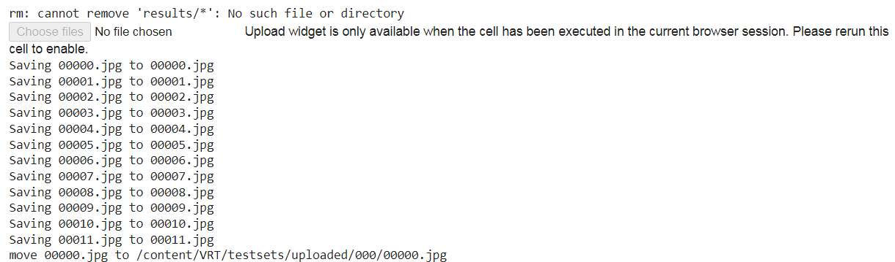

import os

import glob

from google.colab import files

import shutil

print(' Note1: You can upload a single video/ video frames as a batch. \n Note2: If you just to want to replicate the results in the paper, you can skip this step (we have enabled automatic download in the code).\n Note3: You may need Chrome to enable file uploading!\n Note4: Our model is trained on simple synthetic videos (e.g., bicubic). It may not perform well on real-world videos.\n')

input_folder = None

# upload images

!rm -r testsets/*

!rm -r results/*

os.mkdir('testsets/uploaded')

os.mkdir('testsets/uploaded/000')

uploaded = files.upload()

for filename in uploaded.keys():

  is_image = (filename.split('.')[-1].lower() in ['png','jpeg','jpg','tiff','bmp','tif',])

  input_folder = '/content/VRT/testsets/uploaded/000' if is_image else 'testsets/uploaded'

  dst_path = os.path.join(input_folder, filename)

  print(f'move {filename} to {dst_path}')

  shutil.move(filename, dst_path)

  if not is_image: # image or video

    print(f'extracting the video as frames to {input_folder}/000')

    os.system(f'ffmpeg -i testsets/uploaded/{filename} -qscale:v 1 -qmin 1 -qmax 1 -vsync 0  {input_folder}/000/frame%08d.png')

    os.remove(f'testsets/uploaded/{filename}')

!ls testsets/uploaded/000

# utils for visualization

import cv2

import matplotlib.pyplot as plt

from pathlib import Path

def display(img1, name='input'):

  total_figs = 5

  fig = plt.figure(figsize=(total_figs*12, 14))

  ax1 = fig.add_subplot(1, total_figs, 1)

  plt.title(f'Frame 0 ({name})', fontsize=30)

  ax1.axis('off')

  ax2 = fig.add_subplot(1, total_figs, 2)

  plt.title(f'Frame 1 ({name})', fontsize=30)

  ax2.axis('off')

  ax3 = fig.add_subplot(1, total_figs, 3)

  plt.title(f'Frame 2 ({name})', fontsize=30)

  ax3.axis('off')

  ax4 = fig.add_subplot(1, total_figs, 4)

  plt.title(f'Frame 3 ({name})', fontsize=30)

  ax4.axis('off')

  ax5 = fig.add_subplot(1, total_figs, 5)

  plt.title(f'Frame 4 ({name})', fontsize=30)

  ax5.axis('off')

  ax1.imshow(img1[0])

  ax2.imshow(img1[1])

  ax3.imshow(img1[2])

  ax4.imshow(img1[3])

  ax5.imshow(img1[4])

img = []

for path in sorted(Path('/content/VRT/results').rglob('*.png'))[:10]:

  img.append(cv2.cvtColor(cv2.imread(f'{path}'), cv2.COLOR_BGR2RGB))

display(img, 'VRT output')

**SYSTEM TESTING**

**7. SYSTEM TESTING**

**7.1 UNIT TESTING**

**HOME PAGE**

|  |  |  |  |  |
| --- | --- | --- | --- | --- |
| **Test case No.** | **Action** | **Expected output** | **Actual Output** | **Result** |
|  |  |  |  |  |
| 1 | Hover Let’s Begin button | Animates the let’s begin button | Animates the button with some neon effect | Pass |
| 2 | Click Let’s begin | Starts a window animation and then enters into the tech suite | Started a window animation and reached the tech suite | Pass |

7.1.1 - TESTING-HOMEPAGE

**TRAINING SCREEN**

|  |  |  |  |  |
| --- | --- | --- | --- | --- |
| **Test case No.** | **Action** | **Expected output** | **Actual Output** | **Result** |
| 1 | Select invalid numbers in form | Displays error message | Displays error message | Pass |
| 2 | Click Let’s try button | Opens a modal with the estimated time left to train the model | Opens a modal with estimated time left | Pass |
| 3 | After neural network is trained | Redirects to screen which has previous results | Redirects to screen which previous record | Pass |

7.1.2 - TESTING-TRAINING SCREEN

**RESOURCES SCREEN**

|  |  |  |  |  |
| --- | --- | --- | --- | --- |
| **Test case No.** | **Action** | **Expected output** | **Actual Output** | **Result** |
| 1 | Move around a card | Creates an hover effect with deep shadows | Creates an hover effect with deep shadows | Pass |
| 2 | Click on Download button of a resource card | Opens a google drive link containing that particular file | Opens a google drive link containing that particular file | Pass |
| 3 | Move around the footer icons | Displays the link social media | Displays the social media | Pass |

7.1.3 - TESTING-RESOURCES

**Results Screen**

|  |  |  |  |  |
| --- | --- | --- | --- | --- |
| **Test case No.** | **Action** | **Expected output** | **Actual Output** | **Result** |
| 1 | Click on the right arrow on the car | Redirects to a screen with charts and training summary | Redirects to a screen with charts and training summary | Pass |
| 2 | Zoom In or Zoom out on the charts | Zoom in enhances the graph and zoom out shrinks the graph | Zoom in enhances the graph and zoom out shrinks the graph | Pass |
| 3 | Click Show Model Summary button | Opens a drawer with neural network architecture | Opens a drawer that has a neural network architecture | Pass |

7.1.4 - TESTING-RESULT SCREEN

**Integration testing – Testing Bridge between Front-end and Back-end:**

|  |  |  |  |  |
| --- | --- | --- | --- | --- |
| **Testing the Rest- API Bridge between Angular & Flask** | | | | |
| **Test case** | **Action** | **Expected Result** | **Actual Result** | **Status** |
| 1 | Hit the /run API from the Front-end | Run the ML algorithm and saves the timestamp logs | Ran the ML algorithm and saved the model configuration as timestamp | Pass |
| 2 | Hit the /charts REST-API | Returns a list of timestamp logs of trained ML models with the configuration details | Returns a list of timestamp logs of trained ML model with the configuration details | Pass |
| 3 | Hit the /charts/<log>  REST-API | Returns a configuration file from the server | Returns a configuration file from the server | Pass |
| 4 | Hit the /plots  REST-API | Returns a particular plot requested by the client | Returned the requested plot from the server | Pass |
| 5 | Hit the /data REST-API | Returns a particular data file from the server | Returns a particular data file from the server | Pass |

7.1.4 - INTEGRATION TESTING

**7.2 INTEGRATION TESTING**

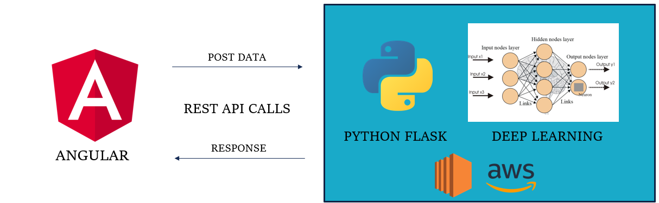

Figure 7.2.1 - INTEGRATION ARCHITECTURE

**7.3 TEST CASES & REPORTS / APPENDICES**

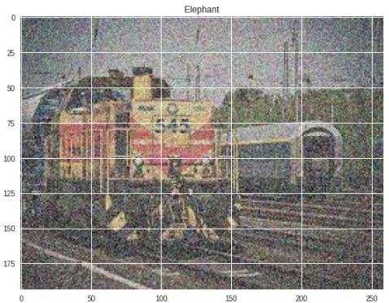

Figure 7 - SCREEN CAPTURE 1

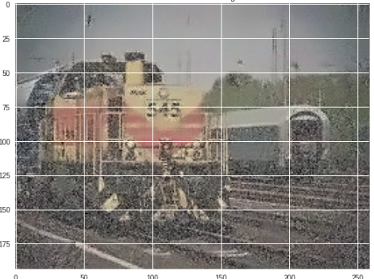

Figure 8 - SCREEN CAPTURE 2 BY FAST MEANS DENOISING

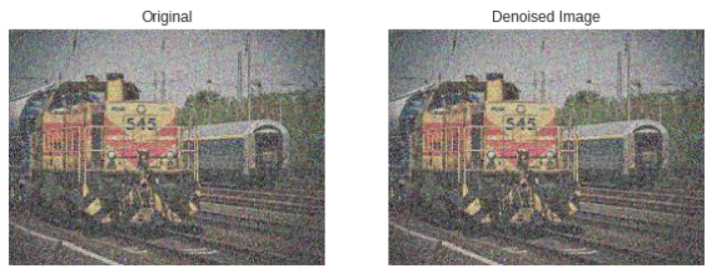

Figure 9- SCREEN CAPTURE 3 DENOISE OF CHAMBOLLE

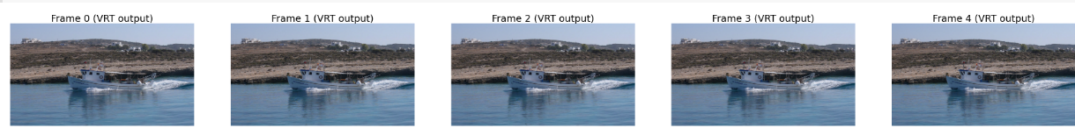

Figure 10- SCREEN CAPTURE 4 FRAMES OF INPUT VIDEO

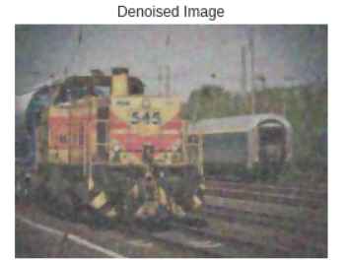

Figure 11- SCREEN CAPTURE 5 by VRT METHOD

# CONCLUSION

**8. CONCLUSION**

**8.1 Conclusion and Future Enhancements**

Restoration decoding plays an important role in restoration machine interfaces by helping disabled persons in expressing and promoting the development of the restoration mechanism. The development of functional Magnetic Resonance Imaging (FMRI), it has become an effective tool in understanding restoration activity. Our future work includes applications of our method to FMRI mental illness classiﬁcation problem.

This will help the neurologist to better understand the health conditions of a paralyzed patient. It can be evolved to produce the dream visuals of a person which is still a mystery to solve. This can open doors to several mysteries behind neurology. Still we are at 21st century but storing and playing a dream is still an issue. With the help of this technology, we can be able to reconstruct the dream using Generative Adversarial Neural network (GAN) networks.

# APPENDICES

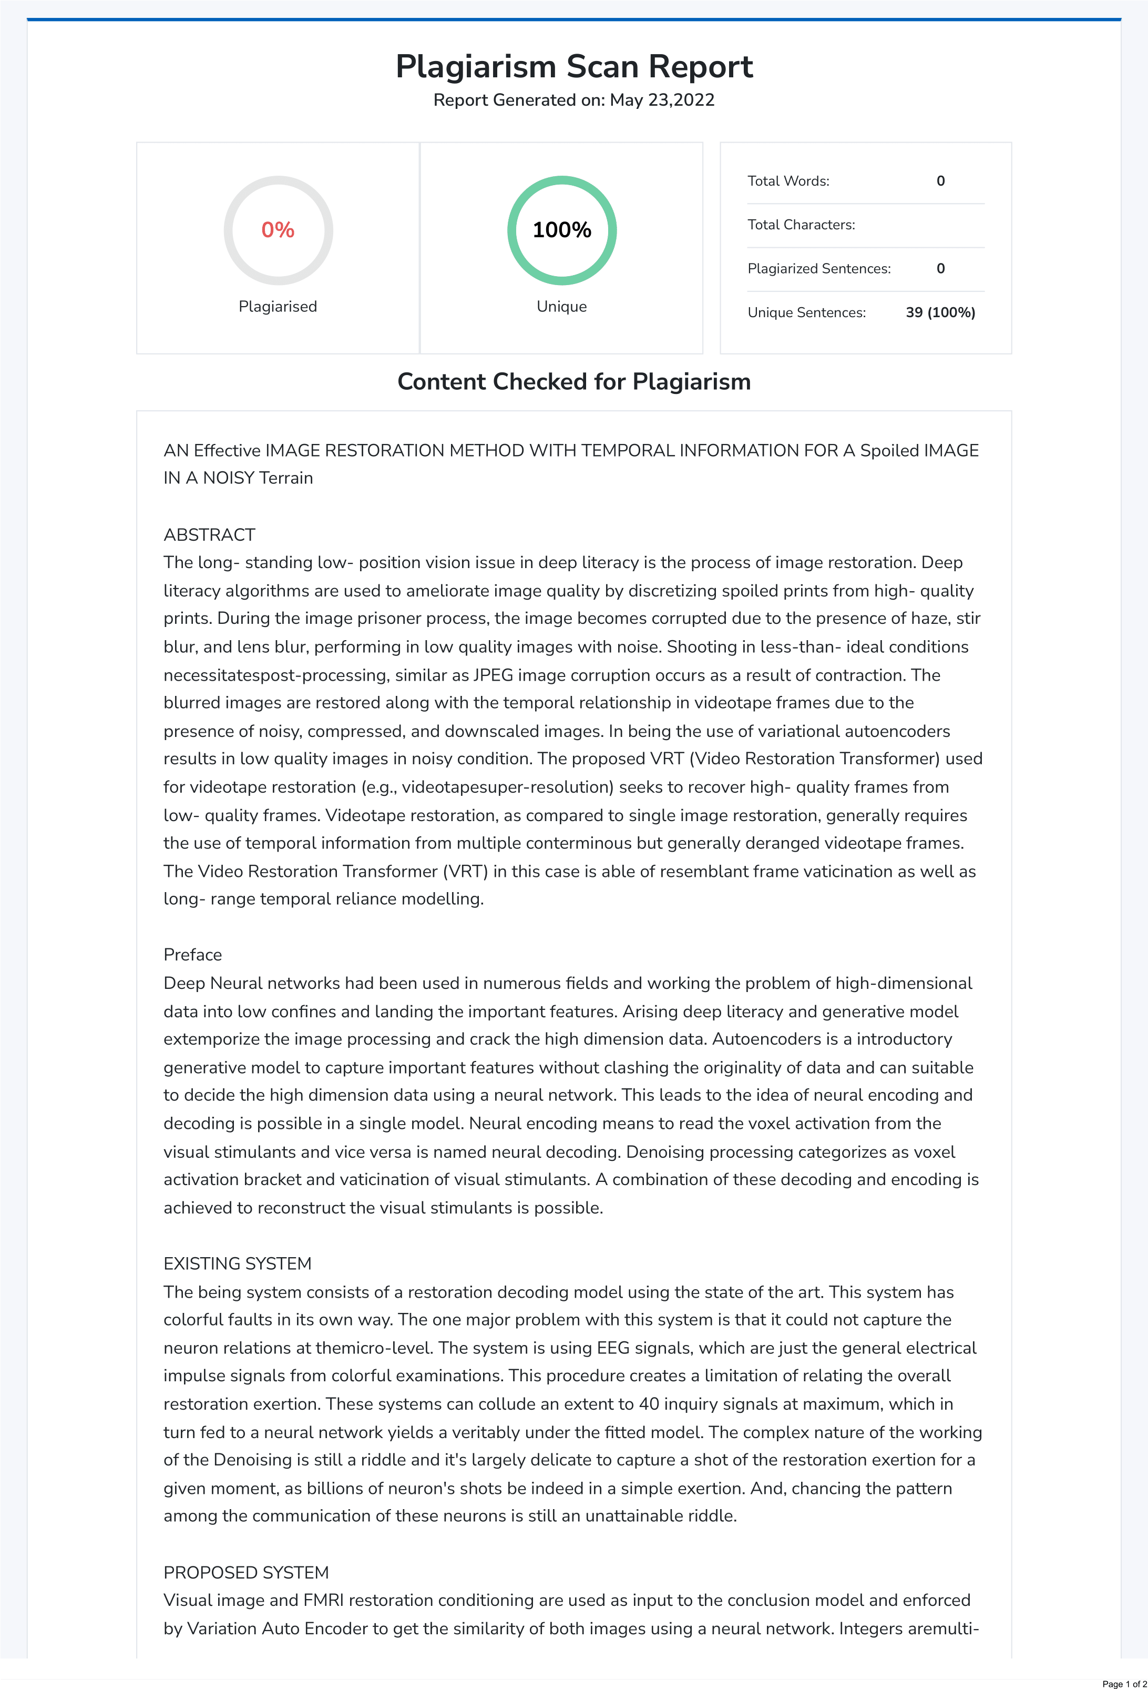

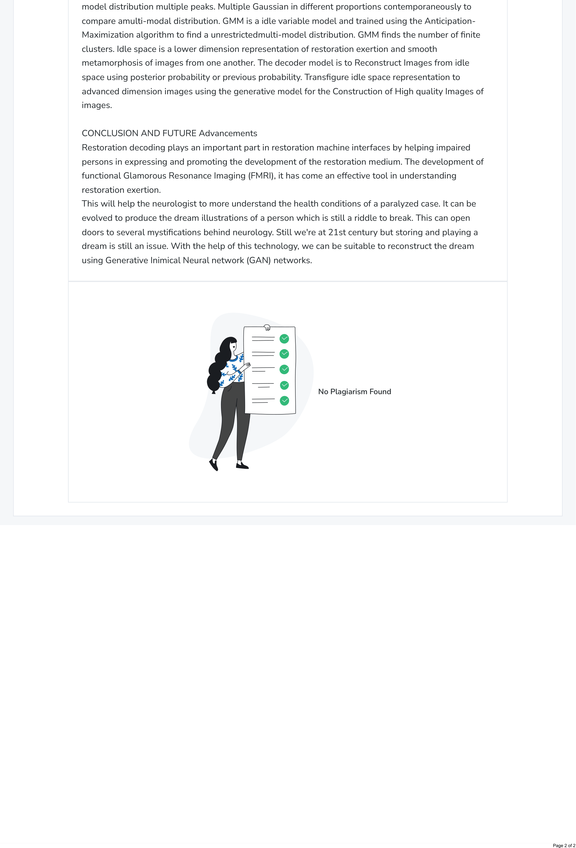

**REFERENCES**

**REFERENCES**

1. Zhang, Yulun et al. “Residual Dense Network for Image Restoration.” *IEEE Transactions on Pattern Analysis and Machine Intelligence* 43 (2021): 2480-2495.
2. Zhang, Yulun et al. “Residual Dense Network for Image Super- Resolution.” *2018 IEEE/CVF Conference on Computer Vision and Pattern Recognition* (2018): 2472-2481.
3. Zhang, Yulun et al. “Residual Non-local Attention Networks for Image Restoration.” *ArXiv* abs/1903.10082 (2019): n. pag.
4. Liu, Chuangchuang et al. “Multi-Scale Residual Hierarchical Dense Networks for Single Image Super-Resolution.” *IEEE Access* 7 (2019): 60572-60583.
5. Liu, Jie et al. “Residual Feature Aggregation Network for Image Super- Resolution.” *2020 IEEE/CVF Conference on Computer Vision and Pattern Recognition (CVPR)* (2020): 2356-2365.
6. Muqeet, Abdul et al. “HRAN: Hybrid Residual Attention Network for Single Image Super-Resolution.” *IEEE Access* 7 (2019): 137020-137029..
7. Cheng, Guoan et al. “Encoder-Decoder Residual Network for Real Super- Resolution.” *2019 IEEE/CVF Conference on Computer Vision and Pattern Recognition Workshops (CVPRW)* (2019): 2169-2178.
8. Li, Yanchun et al. “Lightweight Single Image Super-resolution with Dense

Connection Distillation Network.” *ACM Transactions on Multimedia Computing, Communications, and Applications (TOMM)* 17 (2021): 1 - 17.

1. Liu, Jie et al. “Memory Recursive Network for Single Image Super- Resolution.” *Proceedings of the 28th ACM International Conference on Multimedia* (2020):
2. Sun, Bin et al. “Hybrid Pixel-Unshuffled Network for Lightweight Image Super-Resolution.” *ArXiv* abs/2203.08921 (2022):
3. Zhang, Xinyan et al. “Image Restoration via Deep Memory-Based Latent Attention Network.” *IEEE Access* 8 (2020): 104728-104739.
4. Hang, Yucheng et al. “Attention Cube Network for Image Restoration.” *Proceedings of the 28th ACM International Conference on Multimedia* (2020).
5. Tirer, Tom and Raja Giryes. “Image Restoration by Iterative Denoising and Backward Projections.” *IEEE Transactions on Image Processing* 28 (2019): 1220- 1234.
6. Unni, V. S. et al. “LINEARIZED ADMM AND FAST NONLOCAL DENOISING FOR EFFICIENT PLUG-AND-PLAY RESTORATION.” *2018 IEEE Global Conference on Signal and Information Processing (GlobalSIP)* (2018): 11- 15.
7. Wu, Zihui et al. “Online Regularization by Denoising with Applications to Phase Retrieval.” *2019 IEEE/CVF International Conference on Computer Vision Workshop (ICCVW)* (2019): 3887-3895.